B’n’B
[Big and Beautiful]

4 wall line dance: 32 count. Beginner/Intermediate
Choreographed by: Elina Kärkkäinen Heed (December, 2007. Mullsjö, Sweden)
Music suggestion: ‘Big Girl [You Are Beautiful]’ by Mika from ‘Life in cartoon motion’ CD.

Steps Actual footwork

Section 1 Step right, Twist, ¼ Turn right, Step back, Coaster-step, Point
1 - 2 Step right to right side, Swivel heels to right,
3 - 4 Swivel heels to left and ¼ turn to right, Step right back,
5 - 6 Step left back, Step right next to left,
7 - 8 Step left forward, Point right toe to right side,

Section 2 Wave, Full turn right, Right chasse
1 - 2 Cross right foot over left, Step left to left,
3 - 4 Cross right foot behind left, Step left to left side and ¼ turn to left,
5 - 6 ¼ turn right and step right to right, ½ turn right and step left to left,
7 & 8 Step right to right, Step left next to right, Step right to right,

Section 3 Cross-rock, ¼ turn left and shuffle, Step, Point, 2 x heelbounce with ¼ turn right
1 - 2 Cross rock left over right, Recover onto right,
3 & 4 ¼ turn left and step left forward, Step right next to left, Step left forward,
5 - 6 Step right forward, Point left toe to left side,
7 - 8 Drop left heel and ¼ turn right, Drop left heel again

Section 4 Walk back x 3, Point, 4 x heelbounce
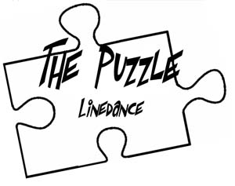
1 - 3 Walk back – right, left, right,
4 Point left toe to left side,
5 - 8 Drop left heel 4 times in the floor.

Repeat

www.thepuzzle.info.se

